INTERNSHIP
TASK 1
  - FILE HANDLING UTILITY:
INSTRUCTIONS:
CREATE A JAVA PROGRAM TO READ WRITE AND MODIFY TEXT FILES
DELIVERABLE:SCRIPT DEMONSTRATE A SCRIP DEMONSTRATING FILE OPERATIONS WRITE CLEAR DOCUMENTATION
OUTPUT:

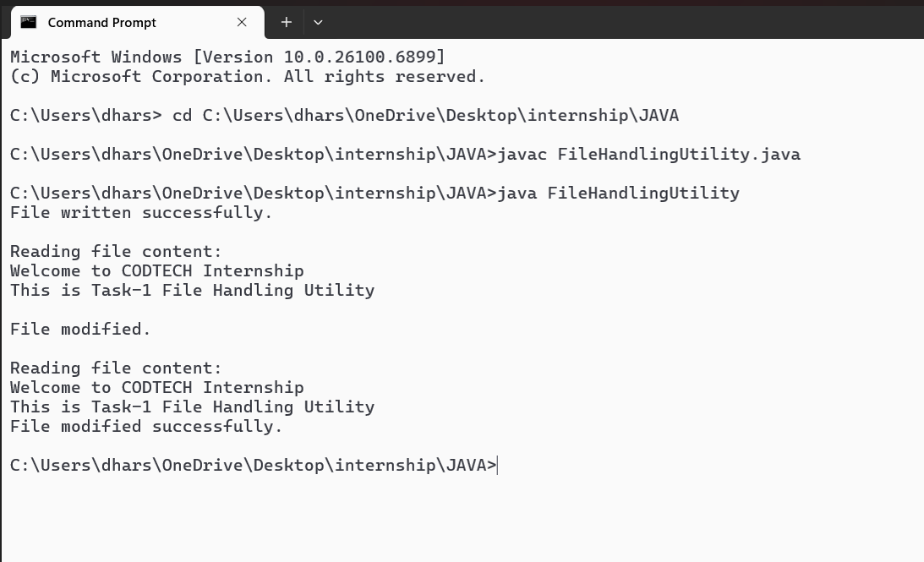

TASK 2:
REST API CLIENT
INSTRUCTIONS:
WRITE A JAVA APPLICATION THAT CONSUMES A PUBLIC REST API(E.G,FETCHING WEATHER DATA)AND DISPLAYS THE DATA IN A STRUCTURED FORMAT
DELIVERABLE:A JAVA PROGRAM THAT HANDLES HTTP REQUEST AND PARSES JSON RESPONSES
OUTPUT:
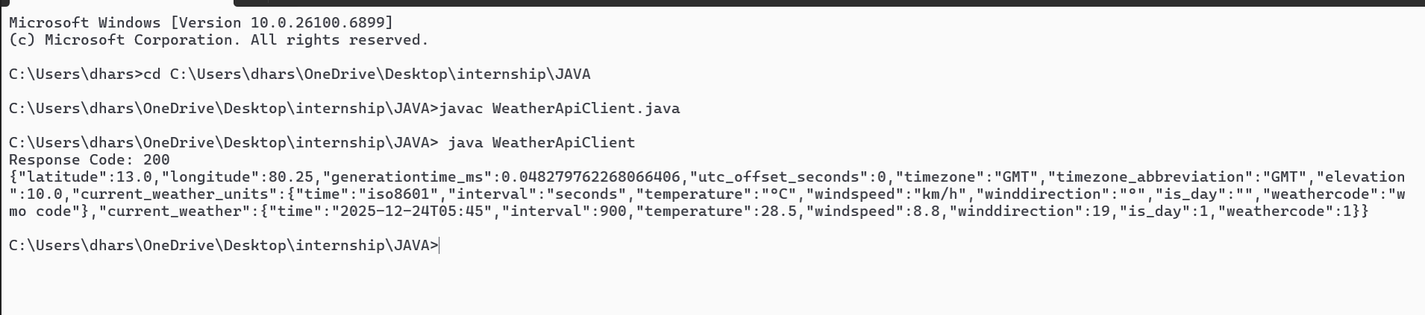

TASK 3:
MULTITHREADED CHAT APPLICATION
INSTRUCTIONS:
BULID A CLIENT-SERVER CHAT APPLICATION USING JAVA SOCKETS AND MULTITHEREADING TO HANDLE MULTIPLE USERS
DELIVERABLE:A FUNCTION CHAT APPLICATION WITH A SERVER AND MULTIPLE CLIENTS COMMUNICATION IN REAL TIME
OUTPUT:
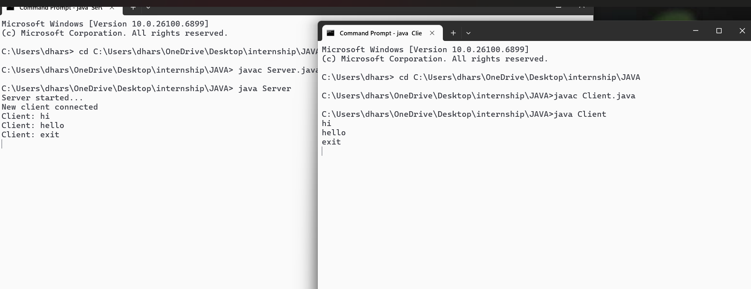

TASK 4:
AI-BASED RECOMMENDATION SYSTEM
INSTRUCTIONS:
BUILD A RECOMMENDATION SYSTEM USING JAVA AND LIBRARIES LIKE APACHE MAHOUT TO JAVA TO SUGGEST PRODUCTS OR CONTENT BASED ON USER PREFERENCES
DELIVERABLE:A JAVA PROGRAM WITH A WORKING RECOMMENDATION ENGINE AND SAMPLE DATA
OUTPUT:

